# B/W Toolbox instructions:

This toolbox performs a graph approach analysis by calculating the connections of ROIs **between** and **within** networks. It output several excel files that can be used for any statistical analysis. This toolbox can be used for any type of data (neuroimaging ...) as long as the input files are correctly prepared.

1. Download and Open Matlab in the B/W toolbox folder.
2. Type **BW** in the MATLAB command line and press Enter.

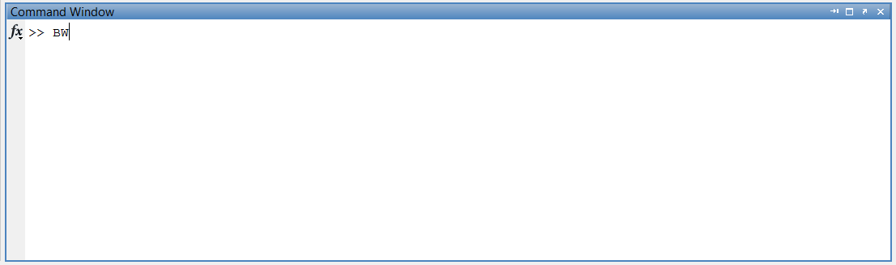

Figure : Type BW to run toolbox

1. Define the threshold between 0 and 1 asked by B/W toolbox in the command line. For instance, 0.2 is a good choice. This threshold is applied to correlation values when counting the B/W connections.

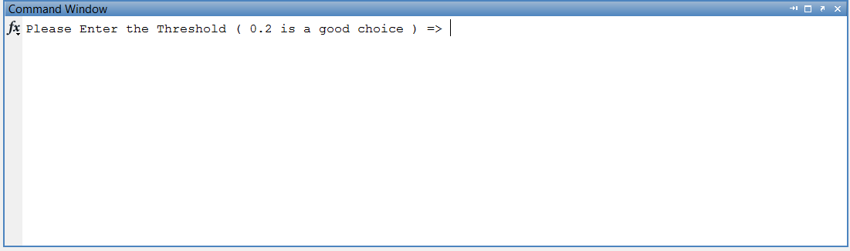

Figure : Define threshold, usually 0.2 is fine

1. Select the folder (which must be already created) in which the results will be saved.
2. Select the ***.mat*** file which includes the correlation values per subject and ROIs names. This file is the CONN toolbox output. If you would like to create your own ***.mat*** file instead of using CONN result, you need to respect the naming convention of CONN ***.mat*** file.
   1. If you create your own .mat file instead of CONN toolbox results, your file needs to have a structure called “Z” which is a 3D matrix (m by m by s ) including scores (correlation scores i.e.) per subject. m is the number of ROIs (nodes) and s in the number of subjects (samples). For examples, in an experiment, there are 47 nodes and 96 samples which results in a 47x47x96 matrix.
   2. The scores (correlation scores must be normalized between 0 and 1).
3. Select the excel file which includes the information about the order of ROIs and number of Modules. (See Appendix and attachment)
4. If your MATLAB supports Parallel Computing toolbox, you enter “1” if not enter “2”. Due to some version conflict, the Parallel Computing may not work properly. You are encouraged to run B/W without Parallel Computing toolbox.

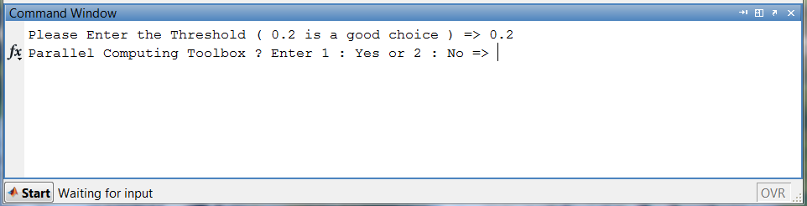

Figure : You need to enter 1 for parallel processing or enter 2 for normal processing

1. To run this code, you need to use a PC (Windows) with a Microsoft Excel already installed.
2. The toolbox generates four sets of results:
   1. Between and Within Measures per subject
      * File name: Subject_???.xlsx (Subject_1.xlsx for subject #1)
   2. Summary of B/W measures for all subjects in one file
      * Summary_report.xlsx
   3. Correlation values for all subjects stored in one excel file
      * CorrMat_allsubjects.xlsx
   4. Matlab structure including all the results mentioned above
      * BW_results.mat
3. If you have the parallel computing toolbox installed in MATLAB, the code will run in parallel for when generating per subject file.
4. Do not open or close Excel while the code is running.
5. The toolbox provides you an option to re-assign the networks and also an option of using sub networks. All you need to do is to update / correct your excel file. See the Appendix for more information.

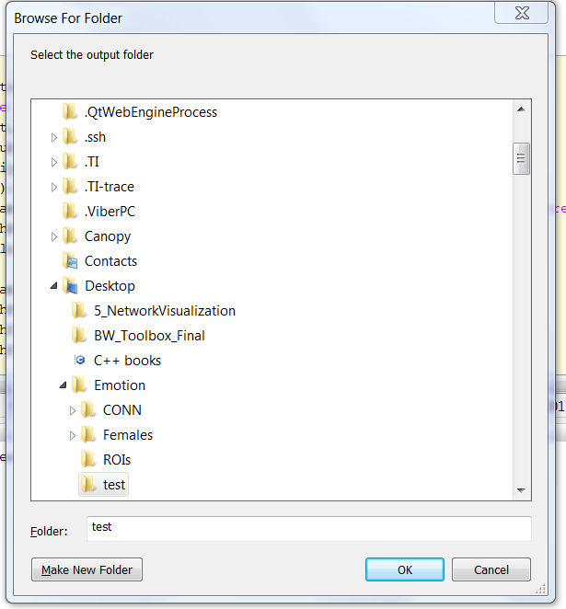

Figure : You select the output folder (left).

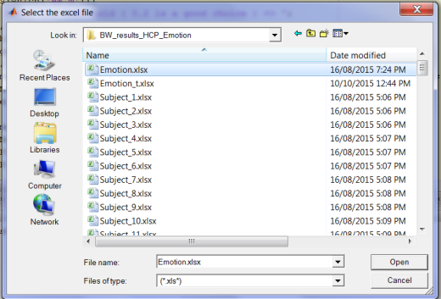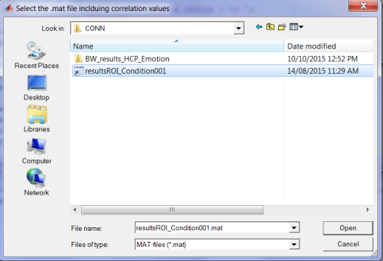

Figure : Select the .mat file (CONN result) (left). Select the excel file including ROIs and Modules information)(Right )

# Appendix:

Between and Within Measures definition: (The equivalent of excel functions is provided, see also the example attached)

**MeanCorr** =AVERAGEIF(B2:B27,">0")

Average of correlations between a given ROI (column in the excel file) and all other ROIs (within and between modules).

**MeanCorr_W**=AVERAGEIF(B2:B9,">0")

Average of correlations for a given ROI (column in the excel file) within a module or network

**MeanCorr_B**=AVERAGEIF(B10:B27,">0")

Average of correlations between a given ROI (column) and other modules or networks meaning that we take average over the correlations of a given ROI with the ROIs which belong to the other modules (that they do not belong to the network of the given ROI)

**MeanCorr_All** =AVERAGEIF(C3:I27,">0")

Average of correlations between a given ROI (the corresponding block) and all other ROIs (within and between networks)

**Within**=COUNTIF(B2:B9,">0.2")

The number of correlations for a given ROI within a network greater than threshold (0.2)

**Between**=COUNTIF(B10:B27,">0.2")

The number of correlations for a given ROI between networks greater than threshold (0.2)

**Total Possible_within**

Number of all ROIs within a network - 1 (Assumed there is no connection between a given ROI and its self)

**Total Possible_between**

Number of all ROIs in other networks (Counting all possible connections between a given ROI and all ROIs out of that network)

**Avg_W=** Average of number of Connections within a module divided by all possible connections

**Avg_B**= Average of number of Connections within a module divided by all possible connections

**Total**= Total number all ROIs having correlation values greater than threshold

# Excel file including the ROIs order and Module information:

You need to create an excel file and in the first sheet, you may want to provide detailed information about ROIs and Modules for your track. The first sheet is not read by the toolbox.

In the second sheet, in the first column (starting at A1), you need to enter the order of ROIs existing in the .mat file (CONN result). For example, if you have 26 ROIs and you do not want to change the order, you only need to enter 1 2 3 ... 26 in the first column.



Figure : The 2nd sheet of the excel file - order of ROIs

In the third sheet, you need to provide the modules information. In the first column starting at A1, you will enter the number of ROIs per module. For instance, you have 5 modules so you need to have 5 cells in the column including the number of ROIs per module. Here, there are 8 ROIs in the 1st module, 4 ROIs in the 2nd module, 5 ROIs in the 3rd module, 5 ROIs in the 4th module and finally 4 ROIs in the 5th (last) module. You notice that total number of ROIs is 26.



Figure : The 3rd sheet of excel file - Module information

# Re-assigning the networks:

In order to re-assign the networks, you do not need to repeat the CONN analysis. All you need to do is to change the order of ROIs in the 2nd sheet and correct the 3rd sheet.

For example, we would like to re-assign the ROIs number 4 and 5 from the first module to the second module. Also, we want to swap the ROI number 20 from the 4th module with ROI number 24 from 5th module. In order to that, we update the 2nd sheet based on the new order and also, we update the 3rd sheet as the numbers of ROIs in the some modules have changed.

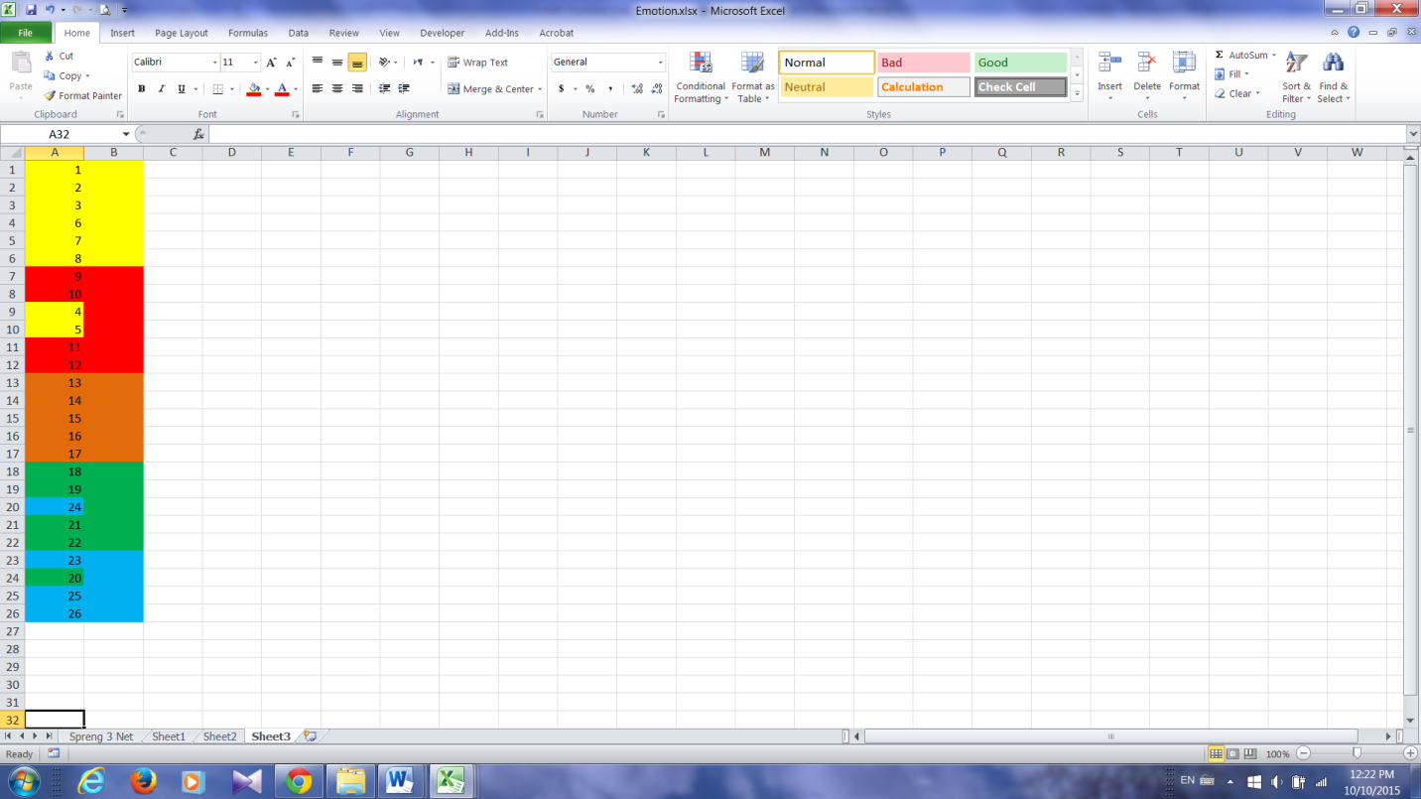 

Figure : Re-assigning the networks (left), Updated 2nd sheet in the excel file (middle), Updated 3rd sheet (right)

# Sub-networks:

In some cases, you want to select some of all ROIs and create sub-networks. First of all, you should keep in mind that in this toolbox, the total number of ROIs in the excel file cannot exceed to total number of ROIs in the CONN. If you want to add a new ROI, you need to repeat the CONN analysis or find a way to correctly add this information to the CONN result (not recommended).

Secondly, for instance, you want to select 10 ROIs and create two new sub-networks and obtain the BW measures only for those two new sub-networks. You select the ROIs, and then you enter the order of them in the 2nd sheet followed by entering the number of ROIs per module in the 3rd sheet. Please see the figures below for more details. Here, the selected ROIS are 1, 4, 7, 10, 11, 12, 18, 20, 21, and 25 where the first 6 ones belongs to the 1st sub-network and the rest belong to the 2nd sub-network.



Figure : Enter 10 Rois in the 2nd sheet (left) and Define the number of ROIs per module in the 3rd sheet (right)

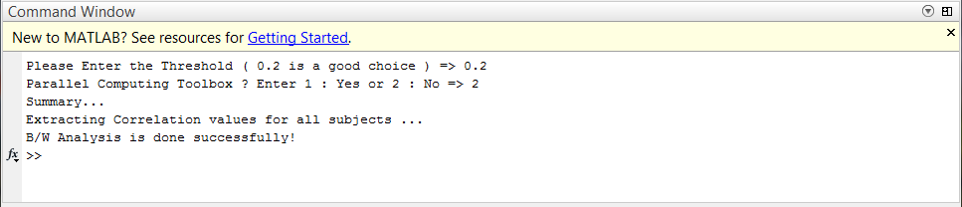

Figure : You will see this message when the B/W toolbox is done.

If you have any question, suggestion or report any bugs, please contact Saman Sarraf at **samansarraf@ieee.org**or**samansarraf@gmail.com**.

Updates:

1 - 20/05/16: Added ‘noexcel’ capability. By calling “**BW noexcel**”, the toolbox only saves the MATLAB structure that saves time and huge computation. It enables users to perform their own results manipulation if no excel files are required.

2 - 21/05/16: Added ‘summary’ capability. By calling “**BW summary**”, the toolbox saves the MATLAB structure and summary and CorrMat_allsubjects excel files.